Fantasy Tracker User’s Manual

Joe Pett

CIS 152 05/01//2018

1. Determine the number of players that are playing. Currently this is an option that is hard coded into the program but can be an input modification to the code for future releases.

**int** pickNum = 1;

player1 = JOptionPane.*showInputDialog*("Enter Player1's name");

String upperPlayer1 = player1.toUpperCase();

owner owner1 = **new** owner(pickNum++, upperPlayer1);

player2 = JOptionPane.*showInputDialog*("Enter Player2's name");

String upperPlayer2 = player2.toUpperCase();

owner owner2 = **new** owner(pickNum++, upperPlayer2);

player3 = JOptionPane.*showInputDialog*("Enter Player3's name");

String upperPlayer3 = player3.toUpperCase();

owner owner3 = **new** owner(pickNum++, upperPlayer3);

1. Once the number of players is determined, run the program and the first input prompt will appear and sequentially the remaining prompts for each player.

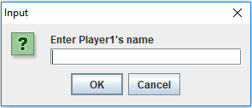

1. After all the players names are entered the next set of prompts appears requesting additional input of the owner/players pick for that order number and sequentially the remaining information for each player.

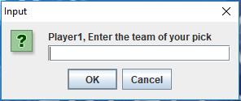

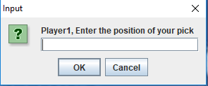

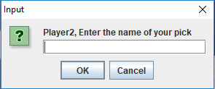

1. If a player’s name is entered twice you receive a message stating the player has already been selected.

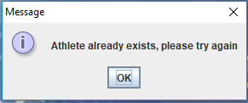

1. Once the round is completed the results are displayed and you will continue to move on to the next round (in the current version the number of rounds is hard coded but can be an input modification to the code for future releases).

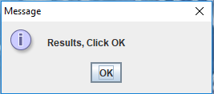

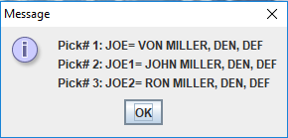

1. Once all the rounds are completed you will see a prompt that displays “End of Draft!” and shows the final results.

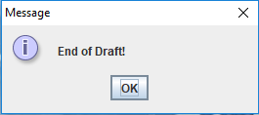

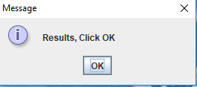

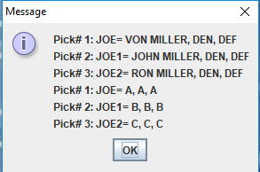

1. The program has ended, and the draft is completed. Enjoy!